Energy Intensive Users Group
Kings Buildings
Smith Square
SW1P 3JJ London
07951 387 408


EIUG Response to the Review of OFGEM

Introduction
- The Energy Intensive Users Group (EIUG) is an umbrella organisation that represents the interests of energy intensive industrial (EIIs) consumers. Its objective is to achieve fair and competitive energy prices for British industry. It represents manufacturers of steel, chemicals, fertilisers, paper, glass, cement, lime, ceramics, and industrial gases. EIUG members produce materials which are essential inputs to UK manufacturing supply chains, including materials that support climate solutions in the energy, transport, construction, agriculture, and household sectors. They add an annual contribution of £29bn GVA to the UK economy and support 210,000 jobs directly and 800,000 jobs indirectly around the country.

- These foundation industries are both energy and trade intensive and continue to invest in the UK. To compete globally, EIIs need secure, internationally competitive energy supplies and measures to mitigate the risk of carbon leakage. However, inward investment, growth and competitiveness have been hampered for years by UK energy costs being higher than those abroad. This has increased the risk of carbon leakage and deterred investments in decarbonisation. In some cases, investment, economic activity, emissions, and jobs have relocated abroad, leading to a subsequent increase in imports, decrease in productivity, and reduction in UK GDP.

- This response focuses on those questions in the call for evidence that are of most interest to EIIs.

TRANSPARENCY AND ACCOUNTABILITY
Redistributive Analysis
- The EIUG encourages the review to recommend including in Ofgem’s KPIs whether its regulatory changes have impacted specific consumer groups disproportionally, in particular energy intensive industries (EIIs), instead of a welfare economic approach only. The latter analysis too often leads to the conclusion that, if there is a positive net present value, the regulatory proposal must be good for all consumers. This is not necessarily the case.
- Ofgem’s secondary duties already set out that it needs to have regard for consumers of electricity in rural areas and the interests of those who are disabled or of pensionable age. EIIs consume large volumes of energy and are therefore particularly exposed to energy prices and any changes to its components – like network charges.

- Over the past years, Ofgem has made regulatory changes that have disproportionately impacted EIIs. Examples include Targeted Charging Review (TCR) – changing how transmission network use of system (TNUoS) are being charged – and the 2nd Balancing and Services (BSUoS) Taskforce – who should be liable for those charges and how to recover them. The outcome of these changes has been a disproportionate increase in these charges for EIIs. According to UK Steel in its latest report on industrial electricity prices; “The [increase] network charges were caused by the implementation of two network charging reforms in April 2023: the Targeted Charging Review (TCR) and the Second Balancing Services Charges Task Force (BSUoS Taskforce), significantly increasing network charges for the most electro-intensive manufacturers. Before the reforms, steel producers paid around £10/MWh, but this increased to over £30/MWh last year and £21/MWh this year” (UK Steel, 2024) – see figure 8 below.

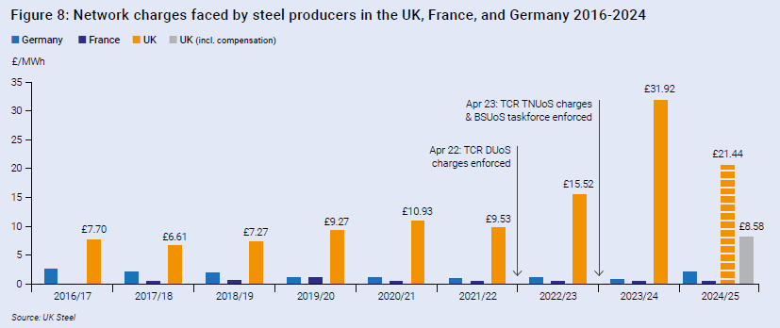
- Ofgem needs to analyse and understand better any cumulative impact of individual regulatory changes on different consumer groups. Though it published a redistributive analysis for EIIs alongside its impact assessment for the targeted charging review for the first time, its appraisal has proven to be way off the mark after implementation.

- Conducting redistributive analyses more consistently for regulatory change proposals would help Ofgem to identify whether the cumulative impact of these changes might particularly negatively impact any consumer groups. A useful KPI in its annual report to Parliament might therefore be the number of redistributive analyses and whether any particular consumer group has been negatively impacted by the cumulative impacts of its regulatory changes.
International Energy Price Comparison
- For Ofgem to publish regular reports comparing how UK industrial energy prices compare internationally, including a breakdown of their components, would also increase transparency and its accountability. UK industrial electricity prices are high relative to those in other countries despite the various relief measures introduced by the Government to reduce the industrial electricity price differentials.

- Ofgem published a research note into GB electricity prices for EIIs in 2021, but the note did not draw any conclusions for its own performance from the research, and it has not published any analysis about how UK industrial energy prices are performing compared to other those in other countries since.

- To increase transparency and accountability of Ofgem, the EIUG encourages the review to include international energy price metrics as KPI in Ofgem’s annual performance report.

Parliamentary Accountability
- The EIUG strongly urges Parliament to introduce regular scrutiny by Parliament of Ofgem’s performance. At a minimum, the relevant select committee in the House of Commons and House of Lords should invite Ofgem to present their annual report and its account and performance therein, but preferably, the select committee should invite Ofgem on a quarterly basis to discuss its performance and its regards to the strategy and policy statement. Additionally, one of the select committees could launch an inquiry into Ofgem’s remit, performance, and alignment with Government alongside or following the Government’s review of Ofgem.

SKILLS AND CAPABILITY
Empowerment
- The EIUG welcomes that Ofgem has put in place a team that looks after issues for non-domestic energy consumers. This conveys an acknowledgement that there are also consumer issues in the non-domestic market and not only the domestic market.

- In the EIUG’s view, Ofgem officials do not always have the skills and empowerment to make meaningful contributions in industry code working groups. Too often, Ofgem has rejected industry code modification proposals on a technicality that Ofgem officials could have communicated early in the code change process. Ofgem leadership should empower its officials to have the skills and confidence to make clear early on in a code modification process what it could accept or not.
REMIT
Risk of Carbon Leakage
- The EIUG strongly urges Government to include those EIIs exposed to the risk of carbon leakage in the Ofgem duty to protect the interest of certain customers. This will align Ofgem’s remit with Government’s objective and policies to minimise the risk of carbon leakage. The actions of Government and Ofgem are currently not aligned and are even contradictory at times. For example, Government introduced a scheme to compensate certain EIIs for network charges. Such alignment with Government has only become more important since Ofgem also has the Net Zero Duty.

- Government can remedy this by adding the following change to the Electricity Act 1989:
Article 3 sub 3 – In performing his duty under subsection (3)(a)(i) above, the Secretary of State or the Director shall take into account, in particular, the protection of the interests of consumers of electricity in rural areas and of consumers at risk of carbon leakage.

Domestic and Non-Domestic Consumes
- Aside from the addition above, the EIUG believes that Ofgem has broadly got the right remit but sometimes questions its interpretation of its remit. There is a perception amongst EIIs that Ofgem has prioritised protecting domestic consumers over protecting non-domestic consumers. A primary example is again the TCR, where TNUoS charges have shifted from domestic to non-domestic consumers, increasing the industrial electricity price differential with other countries.

Coherency
- The EIUG has also noticed that Ofgem does not always have the most strategic approach to regulation but instead has a more of a wack-a-mole approach; i.e. tackle one regulatory issue at a time regardless of whether the changes have any negative impact on other regulations. The TCR is a good example again: to address the proportion of the residual element under the TNUoS charge, Ofgem regulated Triads away, which was a form of demand-side response to minimise inefficient investment in network capacity. As a result, the NESO demand flexibility scheme is now costlier than it would otherwise would have been. Also, Ofgem’s and Government’s ambitions to increase volumes under demand-side response have been undermined.

DELIVERING INVESTMENT AND INNOVATION IN THE TRANSITION
Energy Price and Economic Growth
- The Energy Act 2023 has given Ofgem a new Net Zero duty and the previous Government added Ofgem to the list of regulators that must comply with the growth duty provided for in the Deregulation Act 2015. There can be significant trade-offs between Net Zero and economic growth, and the EIUG would like Government to ask Ofgem how it intends to interpret these new duties with its existing duties and communicate this to stakeholders.

- In terms of what Ofgem might do to support an environment of falling energy prices, it could take the following actions:
- Openly challenge Government for introducing policy costs on retail prices, as this ultimately undermines its primary objective;
- Encourage more long-term gas supply contracts to the UK to minimise gas price volatility;
- (Re-)introduce Triads or a similar instrument to minimise potential inefficient over-invest in the transmission network;
- Allow an increase in the value for the various demand-side response incentives.

- To support higher growth in the wider economy, Ofgem should accept and incorporate the risk of carbon leakage in its regulatory decision-making process to avoid non-domestic consumers face a cumulative cost impact of individual regulatory decisions. This will lower energy prices for those most at risk of carbon leakage and likely attract investment by EIIs, which will have a multiplier effect on the wider economy.

- Ofgem’s regulatory processes are not always sufficiently fast, effective, and user-friendly. For example, it can take Ofgem a long time to decide on industry code modifications that are not controversial and clearly benefit the energy market. This was seen when Ofgem took the 2-month statutory period to decide on the NESO updates for the DFS, though its proposal already reflected a broad industry consensus and Ofgem had nothing to add, as judged by its decision letter. Because of its slow process, some EII have not reflected the DFS in their winter preparations, and NESO lost out on volume.

Arjan Geveke
Director EIUG

