ENERGY INTENSIVE INDUSTRIES CAUTIOUSLY WELCOME THE ELECTRICITY INTERVENTIONS BUT KEY CHALLENGES ON ENERGY REMAIN

Arjan Geveke, Director of the Energy Intensive Users Group (EIUG), said:
“The EIUG broadly welcomes the Government’s interventions to reduce industrial electricity prices, such as the uplift in the network charging compensation scheme and continuing the schemes to compensate certain energy intensive industries (EIIs) for indirect emission costs. However, key challenges with GB’s wholesale electricity prices remain and the Government is vague about delivery of the other electricity measures.”

Notes to editors:

Industrial Electricity Prices
The Government recognises that high industrial electricity prices are one of the most pronounced challenges to the competitiveness of EIIs and the attractiveness of the UK to foreign investment. A recent ONS article shows a substantial fall in their output associated with the period of increasing and high energy prices. Production of UK EIIs was at its lowest point since the start of the available time series in 1990 – see below.
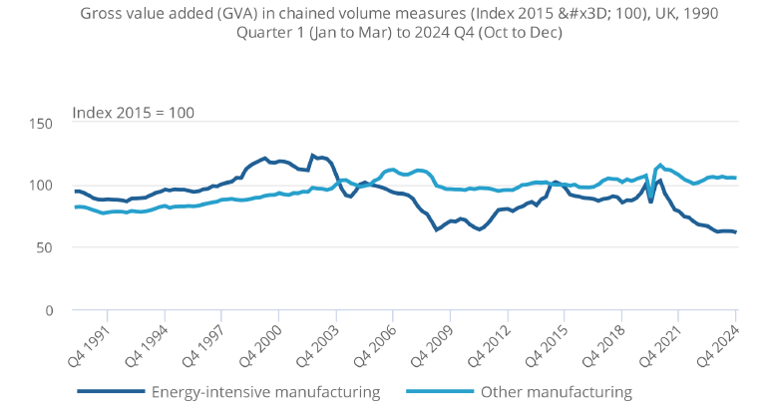

The EIUG therefore welcomes an uplift of the Network Charging Compensation Scheme for those eligible for the British Industry Supercharger package from 2026. This will reduce further the industrial electricity price differential due to network charges with comparable countries, though not all EIIs receive it. The EIUG therefore continues to call for removal of the scheme’s business-level test.

Furthermore, the remaining industrial electricity price difference of £10-16/MWh is caused by “variations in wholesale prices, driven by distinct electricity generation mixes”, according to UK Steel’s electricity price report. High GB wholesale electricity prices remain therefore one of the most pronounced challenges for the competitiveness of EIIs in the UK.

It is a relief to EIIs that Government will continue the schemes to provide compensation for the indirect emission cost due to carbon pricing, though their objective is to mitigate to risk of carbon leakage and not to support “energy efficiency, decarbonisation, and technological innovation” – that was the objective of Industrial Energy Transformation Fund. The Spending Review discontinued this fund, despite HMT having committed to consider future years alongside wider support. Government should now consider how to use UK ETS revenues for decarbonisation support to replace the IETF given the decision to explore linking with EU ETS.

Network Connections and REMA
Finally, the EIUG welcomes a new ‘Connections Accelerator Service’ to provide support for large demand users who want to connect to the grid, including prioritising those that create high-quality jobs and bring the greatest economic value. The EIUG would add those that reduce significant amount of greenhouse gas emissions.

The EIUG is disappointed that Government has not made a decision about Review of Electricity Market Arrangements. It shows that DESNZ has still not assessed its potential impacts, or those of a package of national market reforms, on EIIs.

Foundational Industries
The Government recognises the value of foundational industries, in particular EIIs, to the competitiveness of advanced manufacturing business and the 8 growth sectors it identified. The EIUG will work with the new Supply Chain Centre to inform its analysis of the supply chains for these sectors and to determine what action may be required to ensure economic resilience.

About the EIUG:
The Energy Intensive Users Group (EIUG) is an umbrella organisation that represents the interests of energy intensive industrial (EIIs) consumers. Its objective is to achieve fair and competitive energy prices for British industry. It represents manufacturers of steel, chemicals, fertilisers, paper, glass, cement, lime, ceramics, and industrial gases. EIUG members produce materials which are essential inputs to UK manufacturing supply chains, including materials that support climate solutions in the energy, transport, construction, agriculture, and household sectors. They add an annual contribution of £29bn GVA to the UK economy and support 210,000 jobs directly and 800,000 jobs indirectly around the country.

Contact Information
Arjan Geveke
Director EIUG
07951 387 408
director@eiug.co.uk

